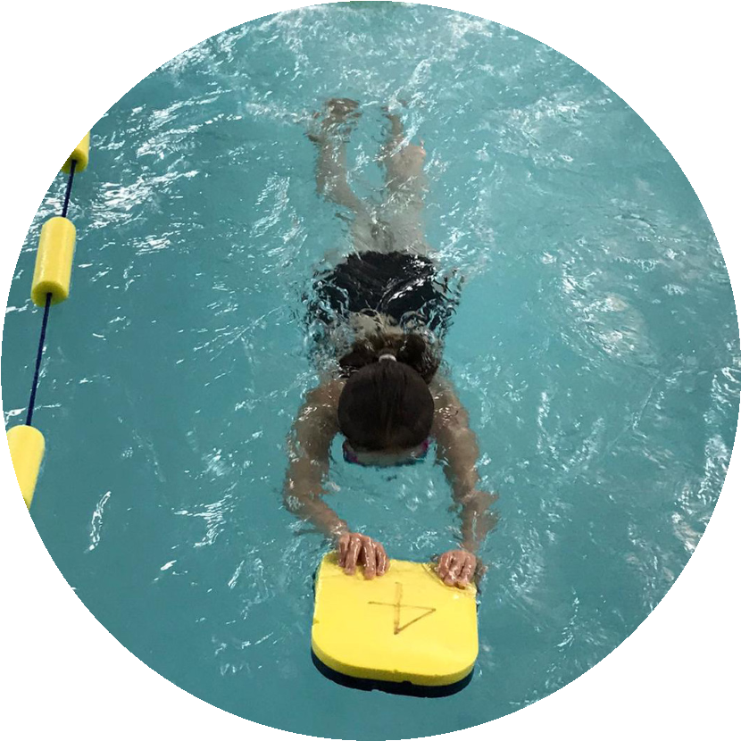
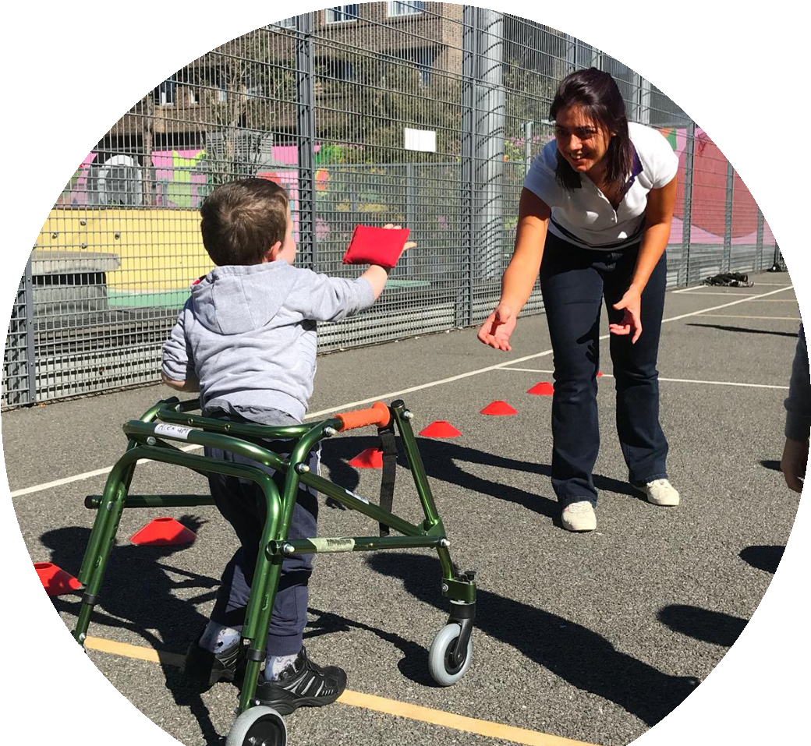
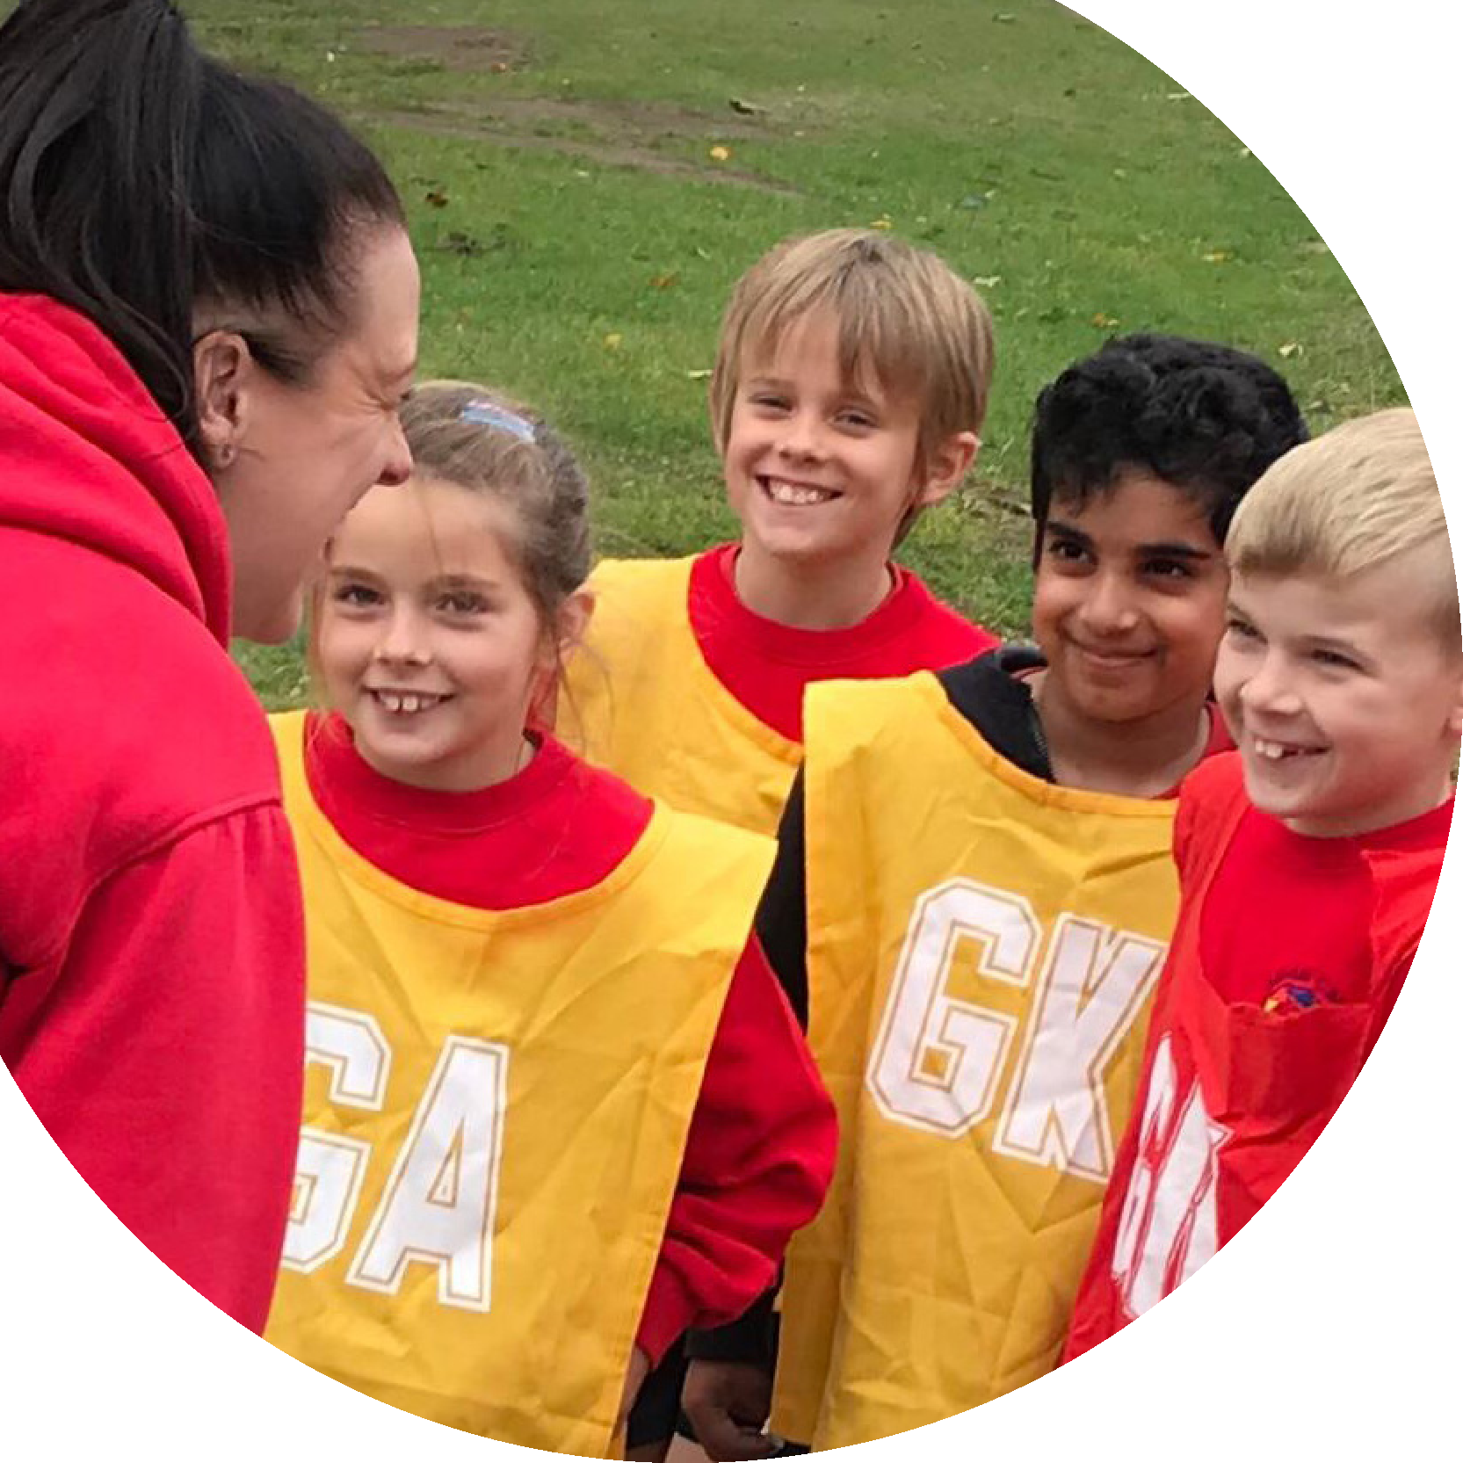
Evidencing the
impact of the
Primary PE and
sport premium

Website Reporting Tool
Revised October 2020
Created by
Commissioned by

st
Support for review and reflection - considering the 5 key indicators from DfE, what development needs are a priority for your setting and your pupils now and why? Use the space below to reflect on previous spend and key achievements and areas for development.
Please note: Although there has been considerable disruption in 2020 it is important that you publish details on your website of how you spend the funding - this is a legal requirement.
N.B. In this section you should refer to any adjustments you might have made due to Covid-19 and how these will influence further improvement.
Key achievements to date until July 2020: | Areas for further improvement and baseline evidence of need:
The profile of PESSPA was raised this year, certainly in light of COVID-19. Children were encouraged to take part in activities in addition to PE lessons including daily mile, Go Noodle and 5 a day. Challenges were set for children to complete both at school and at home.  The school signed up to the school partnership and had a specialist teacher supporting the children before COVID-19 lockdown. Specialist teacher supported with learning ideas to support home learners and set challenges for the children to complete.  Lunchtimes have been developed this year, providing more opportunities for children to be active at lunchtime. PE bags produced for children to continue to be active in their bubbles on the return to school for some of the children. These ensured that the children continued to be active.  The new gym trail and traverse wall was completed in March 2020. Sensory circuits embedded before COVID and staff trained.  Forest school and outdoor sessions have developed this year, for the beginning of the year, EYFS went on forest school sessions and during the lockdown period all of the bubbles went to the forest on a Friday. | Extra activities outside of PE to continue. Activities to be planned in bubbles initially.  Specialist teacher to work alongside class teachers- in particular those new to a year group to support them with the teaching of PE. Sharing of resources needs to be considered across classes.  More PE coaches to be appointed to support lunchtimes and the children's sport and play. Sensory circuits needs to restart, initially with children in bubbles.  Ensure that this is used more and timetabled for the next academic year.  Continue to embed this for the next academic year.
Did you carry forward an underspend from 2019-20 academic year into the current academic year?
YES Delete as applicable
If YES you must complete the following section
If NO, the following section is not applicable to you

If any funding from the academic year 2019/20 has been carried over you MUST complete the following section. Any carried over funding MUST be spent by 31 March 2021.
Academic Year: September 2020 to March 2021 | Total fund carried over: |  | Date Updated:
What Key indicator(s) are you going to focus on?  Keeping children active whilst in bubbles and supporting children’s physical and emotional wellbeing. |  |  |  |  | Total Carry Over Funding:
Intent | Implementation |  |  | Impact
To develop teachers confidence when teaching a recovery curriculum.  Provide children with the opportunities to participate in a range of sporting activities. | Pay for support from a specialist teacher from the sports partnership.  Liaise with JSSE sports. | £6000

Meeting national curriculum requirements for swimming and water safety.
N.B Complete this section to your best ability. For example you might have practised safe self-rescue techniques on dry land.
What percentage of your current Year 6 cohort swim competently, confidently and proficiently over a distance of at least 25 metres?  N.B. Even though your pupils may swim in another year please report on their attainment on leaving primary school at the end of the summer term 2021. | 90%
What percentage of your current Year 6 cohort use a range of strokes effectively [for example, front crawl, backstroke and breaststroke]? | 87%
What percentage of your current Year 6 cohort perform safe self-rescue in different water-based situations? | 87%
Schools can choose to use the Primary PE and sport premium to provide additional provision for swimming but this must be for activity over and above the national curriculum requirements. Have you used it in this way? | No

Action Plan and Budget Tracking
Capture your intended annual spend against the 5 key indicators. Clarify the success criteria and evidence of impact that you intend to measure to evaluate for pupils today and for the future.
 | Academic Year: 2020/21 | Total fund allocated: | Date Updated:
 | Key indicator 1: The engagement of all pupils in regular physical activity – Chief Medical Officers guidelines recommend that primary school pupils undertake at least 30 minutes of physical activity a day in school |  |  |  |  | Percentage of total allocation:
 | Intent | Implementation |  | Impact
 | Your school focus should be clear what you want the pupils to know and be able to do and about what they need to learn and to consolidate through practice: | Make sure your actions to achieve are linked to your intentions: | Funding allocated: | Evidence of impact: what do pupils now know and what can they now do? What has changed?: |  | Sustainability and suggested next steps:
 | Increase engagement of pupils in regular physical activity through access of intra and interschool competitions.  Train year 6 children to be play leaders.  Raise awareness of the Chief Medical Officer’s guidelines that all children should be active for 30 minutes at school.  To develop the engagement of children interacting in sporting activities in their bubbles. | Join schools partnership to enter competitions. Organise and timetable class OAA events and competitions for children to complete in houses.  Children to work with specialist teacher and train to be play leaders. Whilst still in bubbles, children to create videos and activity sheets for children to complete in their classes.  Purchase 5 a day TV, encourage teachers to use other online physical activity websites such as Joe Wicks, Go noodle etc. Timetable daily mile.  Appoint sports coaches from JSSE sports to support sports during lunchtimes. | £900  £500  £500  £2000 | Children are working together and taking part in a range of activities and sports. An additional lockdown has meant that there has been limited experiences for the children to play sports with other schools.  The children have been faced with restrictions throughout the year where they haven’t been able to mix with different classes.  Children in other classes were able to use the resources that were created at lunchtimes.  Children both at home and school have been encouraged to stay active through online platforms at home and at school.  Children were timetabled in classes to participate in different sports at lunchtimes. |  | Re-join the partnership in the next academic year and sign up for the football league to encourage more children to be involved sports out of school.  Train next year’s year 6 children to be play leaders. Create a play leader shed and purchase resources for this.  To continue to encourage these activities next academic year.  Look at employing JSSE sports for more lunchtimes to allow for all classes to attend a lunchtime sports club every week.
 | Key indicator 2: The profile of PESSPA being raised across the school as a tool for whole school improvement |  |  |  |  | Percentage of total allocation:
 | Intent | Implementation |  | Impact
 | Your school focus should be clear what you want the pupils to know and be able to do and about what they need to learn and to consolidate through practice: | Make sure your actions to achieve are linked to your intentions: | Funding allocated: | Evidence of impact: what do pupils now know and what can they now do? What has changed?: |  | Sustainability and suggested next steps:
 | Develop Outdoor Learning throughout the school to enhance mental health and well-being in pupils, as well as develop and promote physical literacy.  Implement OAA days to link children in their classes to their houses to help develop their confidence and participation in sport.  Promote a Recovery Curriculum in sport and being active in the classroom. Involves keeping active and developing confidence and improving mind-set.  All children to attend swimming sessions in the school pool during the summer term. | Forest school opportunities for EYFS off of school premises. Integrate more forest school opportunities in school.  Active maths and Active English programmes to encourage learning outside.  Timetable OAA opportunities across the year in classes and key stages.  Link team building and outdoor learning activities to other subjects e.g. book week.  Look at PE provision map ensuring that the children are accessing a recovery curriculum and that any key skills are being addressed from the previous year group where appropriate.  Organise PE resources and equipment so that different bubbles and classes can use them safely.  Organise with pool carers. Buy additional resources for the children to use so that they don’t have to share resources.  Book training for pool carers to be able to run the pool safely. | £1000  £500  £500  £1000  £1000 | Forest school took place for all children in EYFS up until lockdown. During the Lockdown period the key worker bubbles attended forest school.  OAA events happened with in bubbles throughout the year and challenges were set for home learners.  Training and support given to class teachers by PE lead and specialist teacher on how to support children with the recovery curriculum. More PE opportunities were offered to the children with regular physical breaks including daily mile. Positive impact on children’s well-being. Support given to home learners and challenges also set for the children at home and at school.  All classes received at least one swimming lesson a week, with every other week each class receiving two lessons. |  | Consider more children attending Forest school sessions.  Have a fire pit and forest school resources in school to allow for forest school sessions on the school grounds.  Continue next year with the hope to mix year groups and key stages to allow the older children to support the younger children.  Continue to address any gaps in the curriculum next year.

Key indicator 3: Increased confidence, knowledge and skills of all staff in teaching PE and sport |  |  |  | Percentage of total allocation:
Intent | Implementation |  | Impact
Your school focus should be clear what you want the pupils to know and be able to do and about what they need to learn and to consolidate through practice: | Make sure your actions to achieve are linked to your intentions: | Funding allocated: | Evidence of impact: what do pupils now know and what can they now do? What has changed?: | Sustainability and suggested next steps:
To understand the strengths and weaknesses of all staff related to the teaching of PE and to provide the necessary support and training where needed through a specialist teacher from the sports partnership. | To pay for the package from the SCSSP for a specialist teacher to come into school for one morning a weekend to support and work alongside teachers.  School timetable ensures that the specialist teacher works with at least one teacher a week.  Lesson planning will be completed by the specialist teacher alongside the class teacher. | £6,000 | Specialist teacher support lessons in the autumn term which had an impact on teacher’s confidence in dance and gymnastics.  Specialist teacher provided support during the lockdown to ensure that the children remained active. | Specialist teacher support to continue for the next academic year, especially with an ECT and with the teachers that are working with different year groups.
Key indicator 4: Broader experience of a range of sports and activities offered to all pupils |  |  |  | Percentage of total allocation:
Intent | Implementation |  | Impact
Your school focus should be clear what you want the pupils to know and be able to do and about what they need to learn and to consolidate through practice: | Make sure your actions to achieve are linked to your intentions: | Funding allocated: | Evidence of impact: what do pupils now know and what can they now do? What has changed?: | Sustainability and suggested next steps:
Sensory circuits offered to children who need it across the school in the mornings to improve fine and gross motor skills and attitude and readiness for learning.  To identify pupils who are not engaged with sports and focus on developing their motivation and interest by offering a variety of other activities to try.  To offer a range of after school clubs for the children to attend to meet the needs and interests of the children. | Implement and timetable sensory circuits opportunities for key children before school.  Consider sensory breaks for some children throughout the day.  Train staff.  Questionnaires in school and at home to see how much exercise the children participate in and their strengths and interests.  Look into the different clubs that the school can offer. Speak and liaise with JSSE sports. | £2000 | Sensory circuits had a positive impact on the children’s confidence and readiness for school in the first term. Children attended in year groups.  Sensory circuits was paused for some of the year due to the need for bubbles.  Needs to be implemented next year.  Some clubs restarted including dodgeball, football, multi-sports and dance and musical drama. There was a good attendance at these clubs. | Continue with sensory circuits next year- work with SENDCo to plan for the children that would benefit from attending.  Look into a wider range of clubs for next year- COVID allowing.

Key indicator 5: Increased participation in competitive sport |  |  |  |  |  | Percentage of total allocation:
Intent |  | Implementation |  |  | Impact
Your school focus should be clear what you want the pupils to know and be able to do and about what they need to learn and to consolidate through practice: |  | Make sure your actions to achieve are linked to your intentions: | Funding allocated: |  | Evidence of impact: what do pupils now know and what can they now do? What has changed?: | Sustainability and suggested next steps:
To develop increased participation in all sports through connection with the sports partnership and cluster schools.  To celebrate pupils achievements outside of school to encourage other children to take part in a range of different sports both in and out of school. |  | To participate, where possible with other schools in the cluster in competitive sports.  Share awards and successes in celebration assembly. | £1000 |  | Children have had limited experience of taking part in competitive sports outside of the school. In the summer term, children entered competitions and some football matches took place with other schools.  An increasing amount of children are taking up different sports outside of school. | Sign up again next year for the sports partnership to enable the children to enter different competitions.  Continue to promote this.
Signed off by G McLeod
Head Teacher: | Graeme McLeod
Date: | 7/8/2021
Subject Leader: | DLPeck
Date: | 7/8/2021
Governor: | P Short
Date:

